AAGP Construction Notes

MONTHLY UPDATES Checklist
Public pages
- Main pages:
  - Small Ads
- Mobile Pages:
  - Small Ads
Members Pages
- Main pages:
  - Front Page
    - Newsletter
    - Calendar
    - Member changes
    - BIG copies x 3
  - Archive – Add Calendar & Newsletter
- Mobile Pages:
  - Front Page
    - Newsletter
    - Calendar
    - Member changes
    - BIG copies x 3
  - Archive – Add Calendar & Newsletter
E-Mail to all electronic subscribers

Publisher Formatting
Put a comment in the members pages saying list of committee members is at…..?
Put a “contact” email address hyperlink at the bottom of each page √ (with a capcha??)
Change to a Contact Page
Click on AAGP logo to return to front page of each section
Create a webmaster advert page at www.millmartin.co.uk/MillmartinLtd – the link is at the “created by” bit at page bottom

Link all phone numbers to a phone call

Think about protection from machine/Bot spam??

Each year update the copyright note at the footer

Standard text is Arial 16 20 on public AAGP main pages and on Smartphone pages
Times New Roman somewhere between 16 & 20 – generally 18.67! on members pages (Its now 20)

Site is at | https://www.aagp-provence.com/
 | https://www.aagp-provence.com/index.php
Membership | https://www.aagp-provence.com/membership.php
student application form | https://www.aagp-provence.com/AAGP-student-Membership-Application-form-2014-9.pdf
membership application form | https://www.aagp-provence.com/2018-2019-AAGP-Membership-APPLICATION-FORM-2.pdf
AAGP Statutes | https://www.aagp-provence.com/rulesregs/AAGPstatutes20169thed.pdf
AAGP Rules and Regulations | https://www.aagp-provence.com/rulesregs/AAGPrulesandregs2016.pdf
Contact Us | https://www.aagp-provence.com/contact.php
FAQ | https://www.aagp-provence.com/faq.php
Anglo Info | https://www.angloinfo.com/how-to/france/provence
Small Ad Request | https://www.aagp-provence.com/adrequest.php
 | https://www.aagp-provence.com/members/currentarticles/AGM-September-2017.pdf
MEMBER RECOMMENDATIONS | https://www.aagp-provence.com/members/currentarticles/AAGPDirectory.pdf
 | https://www.aagp-provence.com/members/newsletter/2018/NL-October-2018.pdf
 | https://www.aagp-provence.com/members/newsletter/2018/Cal-October-2018.pdf

membership@aagp-provence.com
info@AAGP-Provence.com
smallads@aagp-provence.com
magazine@aagp-provence.com
president@aagp-provence.com
library@aagp-provence
newmemberswelcome@aagp-provence.com
calendar@aagp-provence.com
teched@aagp-provence.com

do not delete the two directories www and cgi-bin:
- www is meant to host your web pages (* .html * .php)
the pages will be visible using the following address:
http: //www.votre-domaine.tld/
- cgi-bin can be used to install some cgi scripts
http: //www.votre-domaine.tld/cgi-bin

for hosting 60gp type (and therefore not the mailplans):
in the www / panel directory (http: //www.your-domain.tld/panel)
are some useful scripts (use your login and your password to access it):
- phpmyadmin: manage your MySQL database
http: //www.votre-domaine.tld/panel/phpmyadmin

Sincerely
The OVH team

IN XARA:

If you cannot see content on a page check that the “MouseOff” layer is visible

MEMBERS PAGES

ACTIVITIES
Main page has pop-ups. These are available on the list below the page – click on the eye to see them. The “activities” pages at the end are for the small screen version – leave them alone other than making sure the content matches
Small screen page: These are individual pages available at the bottom of the set of pages. This avoids the issue with pop-ups where the pop-up will disappear if you touch/click on the page. Pop-ups are not activated on small screen pages - – leave them alone other than making sure the content matches

SITE BACKUPS
I take a backup of all files on the host server every 3 months;
Last done Sept 10 2018

KEEPING THE SITE UPDATED
Each month:
- Add the new Magazine Calendar and the Membership changes to the Server folders.
- Add Large versions
- Add any new documents (AGM minutes, List of useful info etc)
- Check the size of the Newsletter and Calendar in pdf. Newsletter should be around 15-20 Mb. Calendar around 100-200 Kb

- Members Home Page
- Take a snapshot (JPEG) of the new months front page with a size of about 80Kb (I use a pdf converter to a JPG for the front page – comes in at about 250Kb – then use MS Paint to reduce it to 30% size) – place it in the server yearly (2019) newsletter folder for icons.
- Change the Magazine picture on the members home page
- Change the link to the Magazine and Calendar on the Members Home Page; with both the new calendar and the magazine, set them to open in a new tab
- Change the month in the heading for Magazine and Calendar
- On mobile pages Change the Magazine picture on the members home page
- On mobile pages Change the link to the Magazine and Calendar on the Members Home Page; with both the new calendar and the magazine, set them to open in a new tab
- On mobile pages Change the month in the heading for Magazine and Calendar

- Archive Page
  - Add the new magazine & Calendar
    - To put it on the Archive page make sure the camera icon on the left side margin is selected (under the arrow); click on the blank for the new magazine in the grid; right click on it and click replace photo.
    - To set the web properties for the new photo, make sure the camera icon is still active, right click on the image and click Web Properties….
    - For the calendar icon just select Web Properties from the right click with the arrow icon active
    - With both the new calendar and the magazine, set them to open in a new tab (or those who do not understand the back arrow will have a problem)
  - On mobile pages repeat all above

NB - What I have learned to do is:
- Change the Month names on all buttons (eg March to April) on Public pages, Members pages on both main & mobile pages
- Update the newsletter front page photo on the Members page 1. Copy it and paste it into the mobile page and both main & mobile Archive pages but here set it back to the calendar logo is on top. Beware the month name in the archive block coming to the front! If it does, just delete it or it will mask the hotlink for the front page photo.
- Update the hotlinks for Newsletter, then Calendar & membership changes and then LARGE versions all in blocks so you can copy the first and paste it in the rest on main & mobile pages... Don’t forget to set the link to open in a new page before clicking “Apply”. NOTE also that some links are automatically transferred between the main & mobile pages.... and some are not -its all a matter of how it was set up and, to be honest , its all too difficult to try to make it all automatic!
- Test all links on main & mobile pages in a clean browser – so old pages stored in “history” do not bring up old pages. Note – when people complain of old pages appearing on their computer, its invariably their browser which needs to delete history / relevant cookies or both.

- Update adverts to match the magazine
Inserting adverts - give phone numbers the web link property” tel:NNNNNNNN” and unclick “use common website link colours”. Also unclick “Correct Automatically”
For mail addresses use: mailto:xxxxxxx@xxxx.fr
Link all websites & email addresses but leave “use common website link colours” checked. Make all web pages open (Open link) in a “separate window or tab”
(Confirm common website colours for links is set to default – blue – on “websites” tab in “Web Properties” menu

Format: Line spacing at 110%
0 space before or after lines

For mobile site use the Xara page Small Ads-mobile with a cut & paste from the main Small Ads page but simply re-format as necessary for clarity on a mobile

- Upload new calendar and newsletter to website using the standard name and file convention NL-Month-Year.pdf and Cal-Month-Year.pdf do not leave spaces or these show as odd characters when published
Before publishing use “Preview” for the whole set of pages – check all new links and newsletters etc. Check the correct magazine and calendar open in new pages

Check both the full web pages and then shrink the width to get to the “mobile” or tablet pages
If a page “cannot be found” check the web address. If it has a “%20” in it – perhaps before a file name, then there is an unnecessary space in the hyperlink address

Update 3Recommendations” AGM Minutes, AAGP Statutes etc as they come in
Place old document in the “Old Recommendations” or “Old Forms” etc as appropriate.
Upload new document to the server at “AAGP Documents” in the same location as the old one was. Note the name – amend the link in Xara pages
Update pages to server – Voila!!

WHEN PAGES ARE UPDATED inform the people who only get an electronic version –

FORMS USED on the site:
These are made using the free “JOTFORM” buider https://www.jotform.com/myaccount/profile
Login: tnehjw
Password: AAGPPr0vence
Email : timinaix@gmail.com
Account Type FREE
- 100 monthly submissions
- 10 monthly payment submissions
- 1,000 monthly form views
- 5 total forms
- 100MB total space
- 500 total submission storage
Currently using 5 forms:
- AAGP Small Ads mobile
- Small Ads Main
- AAGP Website feedback
- Small Screen AAGP – Contact us
- AAGP - Contact Us
To change the recipient of the submitted form, click n edit for the appropriate form, Settings, Emails, Notification 1 and change the mail address. There is no need to re-load the form to Xara! Just change the mail on the JotForm site.

If you want to add a form from Xara, click on Insert, Table, then scroll to Forms – click, click on JotForm, login , create or amend the form and “Publish”. At this point click on “Embed” and on “Copy Code” on the top option. Then click on Go or continue or whatever the button is at the bottom of the page…. Xara will then embed it.
Check you have all the elements you created – the formatting on the published page can be problematical so check everything on the web itself…
README File:

Hello,

do not delete the two directories www and cgi-bin:
- www is meant to host your web pages (* .html * .php)
the pages will be visible using the following address:
http: //www.votre-domaine.tld/
- cgi-bin can be used to install some cgi scripts
http: //www.votre-domaine.tld/cgi-bin

for hosting of type 60gp (and therefore not the mailplans):
in the www / panel directory (http: //www.your-domain.tld/panel)
are some useful scripts (use your login and your password to access it):
- phpmyadmin: manage your MySQL database
http: //www.votre-domaine.tld/panel/phpmyadmin

Sincerely
The OVH team

Access to private pages – Password Protection
Put members pages data in www/Members where it will be behind the password
Passwords created at https://www.web2generators.com/apache-tools/htpasswd-generator
Look in “access” folder on Server files (Filezilla); right click on password.txt; use the edit function and specify MS notepad. Generate passwords on site above; replace old ones by new ones; Bob’s your uncle!
~_______________________________________________________________________
There is a folder, /access (not visible to web browsers), on the OVH server which contains a password file, password.txt. This file is maintained by the unix program htpasswd.
It contains user names and passwords used to access the members’ private pages.
Capitalization counts on the user names, so there are three versions: all lower case, First Letter Capitalized, ALL CAPS.
To modify it, delete lines in a text editor (eg MS Notepad),
or use a bash shell to add: navigate to the members directory where password.txt lives and type “htpasswd password.txt username” and it prompts for password and adds a line.
Originally it contained cours:mirabeau, Cours:Mirabeau with passwords encrypted as here:
cours:5vIE4ZzWyZXUs
Cours:ex.VKmZGrmyT6

The /www/members folder contains a file, .htaccess, which contains the following:
AuthName "Member's Section"
AuthType Basic
AuthUserFile /home/aagpprov/access/password.txt
Require valid-user
ErrorDocument 401 http://www.aagp-provence.com/errors/401.php
ErrorDocument 401 http://www.aagp-provence.com/errors/404.php

This causes the apache web server to challenge any user trying to access any file in the /www/members folder for a user name and password, valid ones being in the password.txt file.
HISTORY OF PASSWORDS
Changed to sainte victoire, Sainte Victoire
Changed to paul cezanne
Changed to pablo picasso
Changed to marcel pagnol
Changed to Edith Piaf
Changed to Emile Zola
Changed to Van Gogh
Changed to Guy Fawkes
Changed to Marius Fanny
Added Donald Trump
Changed to King Kong
Changed to AAGP Provence Oct 2018
Oct 2019 it became AAGP and Abracadabra
Nov 2020 it became AAGP and Teapot

PASSWORD .txt FILE 8 September 2019

King:$apr1$eSW36OC1$lR6N2o2K8Z6FcF/rh.zpa0
king:$apr1$sTYkF.xF$PfjY8rROANgNuEfvSJVsk/
KING:$apr1$QjCjCKKC$DJ7sGGPzX2G3JlGHLlzQy1
AAGP:$apr1$k/O1f.z6$/AU5S0iYSWSJq1HdVNP.u.
aagp:$apr1$DNx3KJ8L$3LzjpXCsrhggwx5xMtwMk1

Passwords below this line are not active until they replace the AAGP ones above
Note that the system takes the first match for a "user name" as it goes down
the list so only one password can be active for each exact username

aagp:$apr1$1c6zwr9x$k05K6qmJx6hFjClRfvKbn0
AAGP:$apr1$w7p6xgtf$2hXXQN/w4WP84PGYYMsaa.

Passwords created at https://www.web2generators.com/apache-tools/htpasswd-generator

How to password protect a directory on your website (adapted from OVH)

1. Create the password file
Firstly, you have to create the file which will contain the list of usernames and passwords which are allowed to access the site. Usually, you create a .htpasswd file for this. In the AAGP site they are in a file named “password.txt”. This will then be used by the .htaccess file. It is a simple text file, which contains usernames and their encrypted passwords.
In Windows, you cannot directly create a file named .htaccess or .htpasswd. You must give it another name (eg htaccess.txt), transfer it to your web space and then rename it .htaccess or .htpasswd using your FTP client.
The .htpasswd should not necessarily be in the same location as the .htaccess file. For example, you could place it in the Webroot (the /www folder), and use it to protect different website directories, given that a single .htpasswd file can be used by several .htaccess files. The .htpasswd file and/or the “password.txt” filemust contain one line per user specifying the username and password.
These lines are as follows:
username:encrypted_password
Example for username: “Admin” and password: “ovh1234” this will give the following: Admin:gl0IiOirI2n6M
The encrypted version of the password can be generated here:
https://www.web2generators.com/apache-tools/htpasswd-generator
When the system reads the “password.txt” file to check for access rights it takes the first match for a "user name" as it goes down the list so only one password can be active for each exact username
Once the .htpasswd password has been created, you just have to place it in the “password.txt” file and go to the next step: creating .htaccess files.
Remember to add a carriage return after the encrypted password.

2. Create the .htaccess file
To block access to an entire directory, create a .htaccess text file as follows and place it into the directory you want to password protect.
IMPORTANT, In the following example, you have to replace your_ftp_username with your FTP username, you will find this in your control panel.
AuthUserFile /home/your_ftp_username/www/.htpasswd
AuthGroupFile /dev/null
AuthName "Restricted access"
AuthType Basic
require valid-user
In the example above, your .htpasswd file is located in the /www folder on your web server.

For AAGP .htaccess is placed in the /www/Members folder

AuthName "Members"
AuthType Basic
AuthUserFile /home/aagpprov/access/password.txt
Require valid-user
ErrorDocument 401 http://www.aagp-provence.com/errors/401.php
ErrorDocument 401 http://www.aagp-provence.com/errors/404.php

3. Block access to one or more specific files
To block access to one or more specific files, you just have to add the tags (one FILES tag per file):
<Files test.php>

AuthUserFile /home/your_ftp_login/www/.htpasswd
AuthGroupFile /dev/null
AuthName "Restricted access"
AuthType basic
require valid-user

</Files>

NEWSLETTER FROM PUBLISHER
Transforming Publisher format newsletters into one suitable for the PDF newsletter.

When the files arrive there will probably be a PDF and a PUB file. Save the PUB file to the folder:
D:\AAGP\AAGP Documents\Newsletters\2020\2020 Newsletters\Publisher

The PDF file is probably a direct pdf of the file sent to the printer. This will be a booklet format – ie pages 1 /20 on one sheet, 2/19 on the next etc. You can transform this page by page but it is labour intensive and I’d recommend as only a fallback option.

For the PUB file, open in Publisher.
First, consider removing “picture borders”& Picture effects” from banners etc or these may come out as black borders in the PDF. NB – this may not be necessary so check before taking the time to do it!
These are normally on the AAGP logo on the first pages

2 different ways to remove these depending on how it was done in the first place....:
1. Click the picture with the border etc
Click the “Format” menu
Use the “Picture Effects” tab – “shadow”, “reflection”, “glow” or other one and set to “None”

2. Right click on the picture with the special effect.
Click on “Format Picture”
Click on Shape Effects
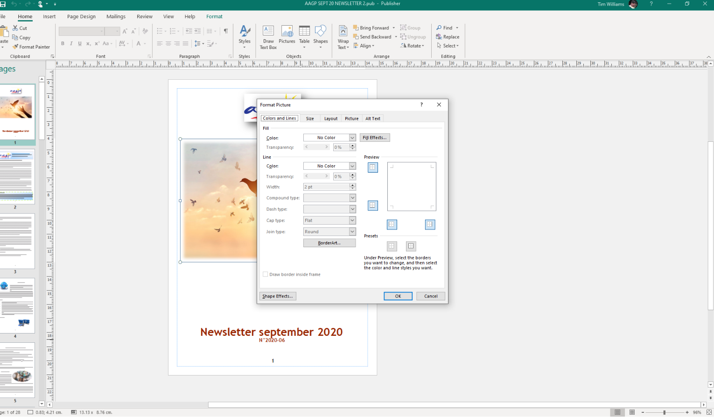

Once effects are removed, select “File” / “Export”
Click on “Create PDF/XPS document”
Select the destination folder for the PDF file
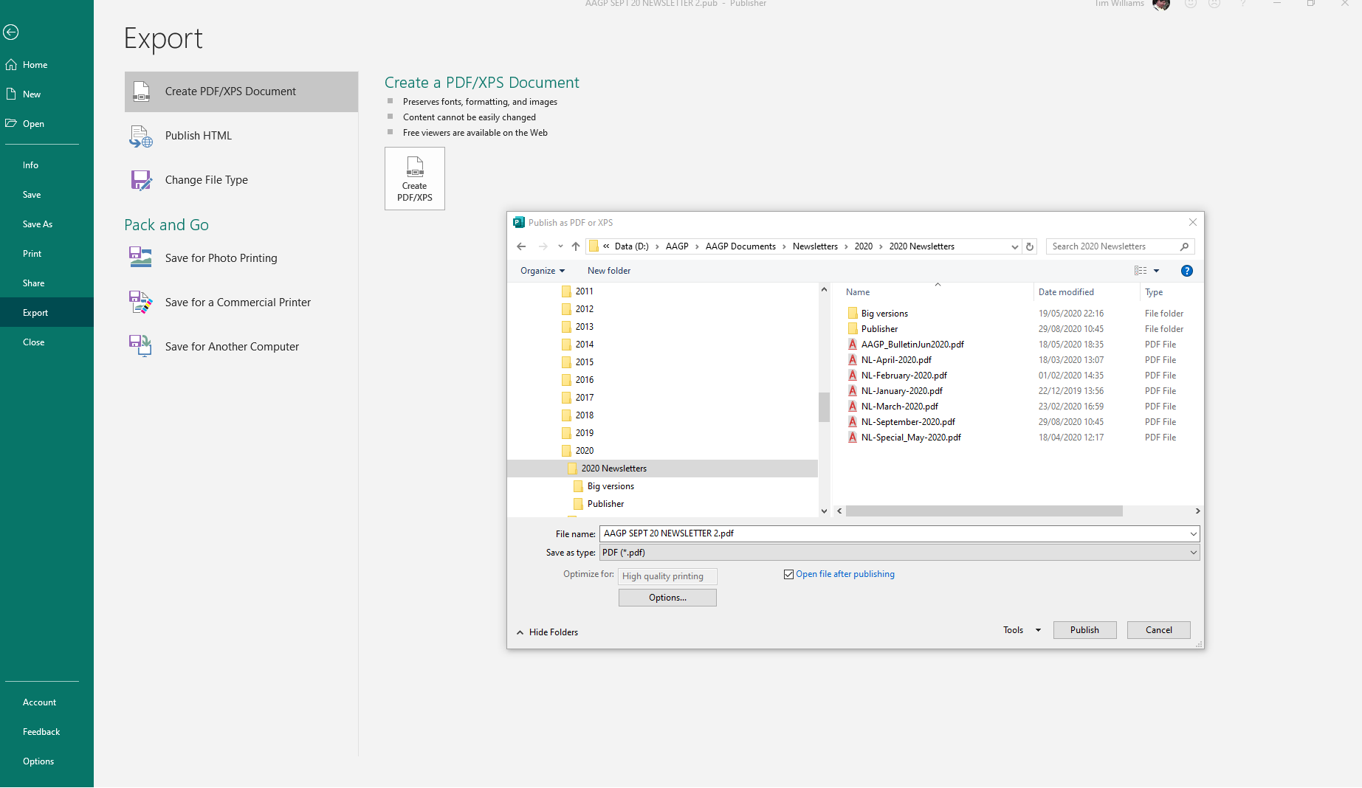
Aim is to save your booklet as a PDF, but before you hit Save… you need to ensure it will save as single sequential pages 1, 2, 3, ...etc
Click on the Optimise for… Options… button which should appear when you choose PDF – at the bottom below “File Type”
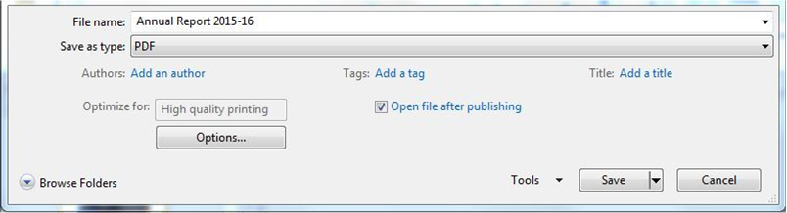

Step 3 – The Publish Options window should open. Click on Print Options in the bottom-left corner.
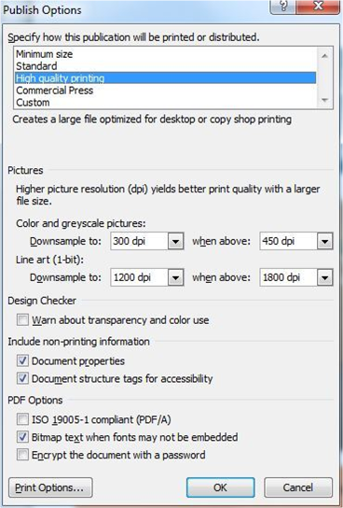
Step 4 – Select “One page per sheet”, and save your document.
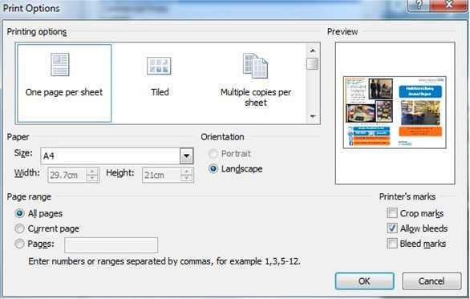

Then click “OK”
Make sure the file name is correct using the standard name convention eg NL-Month-Year.pdf do not leave spaces or these show as odd characters when published

Then click “Publish”
This should then save as one page per sheet
Check the whole document in your PDF reader for black shadows blanks etc which occur occasionally when docs are tranferred to PDF.

THUMBNAIL for Web
Then make the picture thumbnail from the front cover.
I use my PDF software to do this – a conversion to JPG of the first page. There will be free Apps on the net to do it....
The image file is usually around 100 – 400KB size.
The thumbnail reduced from this is best around 20 – 50 KB to assist loading times on the site

BIG VERSIONS for those with sight problems.
These go to a few members who the Membership Sec knows are hard of sight.
The normal text is in a 12 font size. Aim is to raise this 18 throughout the document. You can use 16 where necessary to keep the page complete – such as the “Letter from the Board “

Use Publisher,
Change the page size (“Page Design” menu, “Size” , “Page Setup”, Select Layout type “One page per sheet”; width 15, (or wider if needed??) – height 40 ; margins minimal as you like; [check before clicking “OK” that the page size settings are still as above!!] .... click “OK”
On Menu “View” select “Single Page”
Change the font, expand print borders, remove frills to get data on the page,
Publish as before

If you find photos on the publisher version which you cannot select by clicking on it (or a group) when you want to re-size or move it/them, then do a group select by using th ecursor to define a box area over it /them (start off the active text area) then right click on one of the corner points, Click on “Change Picture”, click on “Reset Picture”, - they will all go back to original sizes etc so you can re-size and position as required.

If you have text on a photo which you cannot reformat to a larger font or a bunch of photos etc placed as a 1 page photo, the option is to copy them onto a word document, edit the image to make the text bigger (crop it out of a copy of the photo if needs be), reformat it on an A4 page or even larger,
Export it as a PDF
Use a PDF editor to add it to the Big Version newsletter PDF as a kind of merge - there will be 2 different page sizes in it but at least it will be readable! Eg. see September 2021

BIG Calendar
Get it in Word format. The calendar comes as a table
Remove all spaces after each pages items
Format all text to 18 size – make the AAGP logo be “n front” of text (right click it, select “Wrap Text” from drop-down, select “In Front of Text”
Rearrange the column spacing to avoid extra lines
Reduce the font size of lines between activities to 8
Remove any extra rows
It should now fit onto 1 page....

Membership Changes

These come as a PDF
To change it to larger format, convert it to a photo (JPG etc )file, place it into a Word document
Copy the photo and place it lower
Crop the title, then the contents asneeded to double the text while keeping the format
Export as a PDF
Save the PDF

